ITA0601 – MACHINE LEARNING
LAB EXPERIMENTS
EXP-11 Task of Credit Score Classification
Dataset 1 – Basic Credit Score Classification
Income | Age | Loan Amount | Credit History | Credit Score
25000 | 22 | 5000 | 1 | Poor
30000 | 25 | 6000 | 1 | Poor
35000 | 28 | 7000 | 1 | Poor
40000 | 30 | 8000 | 1 | Good
45000 | 32 | 9000 | 1 | Good
50000 | 35 | 10000 | 1 | Good
55000 | 38 | 12000 | 1 | Good
60000 | 40 | 15000 | 1 | Good
28000 | 24 | 9000 | 0 | Poor
32000 | 27 | 10000 | 0 | Poor
Python Code:
import pandas as pd
from sklearn.model_selection import train_test_split
from sklearn.linear_model import LogisticRegression
from sklearn.metrics import accuracy_score, classification_report
data = {
"Income": [25000, 30000, 35000, 40000, 45000,
50000, 55000, 60000, 28000, 32000],

"Age": [22, 25, 28, 30, 32,
35, 38, 40, 24, 27],

"LoanAmount": [5000, 6000, 7000, 8000, 9000,
10000, 12000, 15000, 9000, 10000],

"CreditHistory": [1, 1, 1, 1, 1,
1, 1, 1, 0, 0],

"CreditScore": ["Poor", "Poor", "Poor", "Good", "Good",
"Good", "Good", "Good", "Poor", "Poor"]
}
df = pd.DataFrame(data)
df["CreditScore"] = df["CreditScore"].map({
"Poor": 0,
"Good": 1
})
X = df[["Income", "Age", "LoanAmount", "CreditHistory"]]
y = df["CreditScore"]
X_train, X_test, y_train, y_test = train_test_split(
X, y, test_size=0.3, random_state=42
)
model = LogisticRegression(max_iter=1000)
model.fit(X_train, y_train)
y_pred = model.predict(X_test)
print("Actual Values:")
print(y_test.values)
print("\nPredicted Values:")
print(y_pred)
print("\nAccuracy:")
print(accuracy_score(y_test, y_pred))
print("\nClassification Report:")
print(classification_report(
y_test,
y_pred,
target_names=["Poor", "Good"],
zero_division=0
))
new_customer = pd.DataFrame(
[[45000, 33, 9000, 1]],
columns=["Income", "Age", "LoanAmount", "CreditHistory"]
)
prediction = model.predict(new_customer)
if prediction[0] == 1:
print("\nNew Customer Credit Score: GOOD")
else:
print("\nNew Customer Credit Score: POOR")
Output:
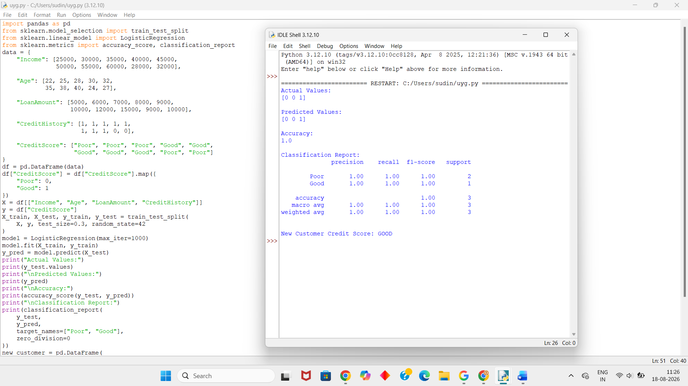
Dataset 2 – Credit Card Customer Classification
Monthly Income | Age | Credit Usage | Late Payments | Credit Score
20000 | 21 | 85 | 4 | Poor
25000 | 24 | 80 | 3 | Poor
30000 | 26 | 75 | 3 | Poor
35000 | 29 | 60 | 2 | Poor
40000 | 31 | 50 | 1 | Good
45000 | 34 | 45 | 1 | Good
50000 | 37 | 40 | 0 | Good
55000 | 39 | 35 | 0 | Good
60000 | 42 | 30 | 0 | Good
65000 | 45 | 25 | 0 | Good
Python Code:
import pandas as pd
from sklearn.model_selection import train_test_split
from sklearn.linear_model import LogisticRegression
from sklearn.metrics import accuracy_score, classification_report
data = {
"MonthlyIncome": [20000, 25000, 30000, 35000, 40000,
45000, 50000, 55000, 60000, 65000],

"Age": [21, 24, 26, 29, 31,
34, 37, 39, 42, 45],

"CreditUsage": [85, 80, 75, 60, 50,
45, 40, 35, 30, 25],

"LatePayments": [4, 3, 3, 2, 1,
1, 0, 0, 0, 0],

"CreditScore": ["Poor", "Poor", "Poor", "Poor", "Good",
"Good", "Good", "Good", "Good", "Good"]
}
df = pd.DataFrame(data)
df["CreditScore"] = df["CreditScore"].map({
"Poor": 0,
"Good": 1
})
X = df[[
"MonthlyIncome",
"Age",
"CreditUsage",
"LatePayments"
]]
y = df["CreditScore"]
X_train, X_test, y_train, y_test = train_test_split(
X, y, test_size=0.3, random_state=42
)
model = LogisticRegression(max_iter=1000)
model.fit(X_train, y_train)
y_pred = model.predict(X_test)
print("Actual Values:")
print(y_test.values)
print("\nPredicted Values:")
print(y_pred)
print("\nAccuracy:")
print(accuracy_score(y_test, y_pred))
print("\nClassification Report:")
print(classification_report(
y_test,
y_pred,
target_names=["Poor", "Good"],
zero_division=0
))
new_customer = pd.DataFrame(
[[42000, 32, 45, 1]],
columns=[
"MonthlyIncome",
"Age",
"CreditUsage",
"LatePayments"
]
)
prediction = model.predict(new_customer)
if prediction[0] == 1:
print("\nNew Customer Credit Score: GOOD")
else:
print("\nNew Customer Credit Score: POOR")
Output:
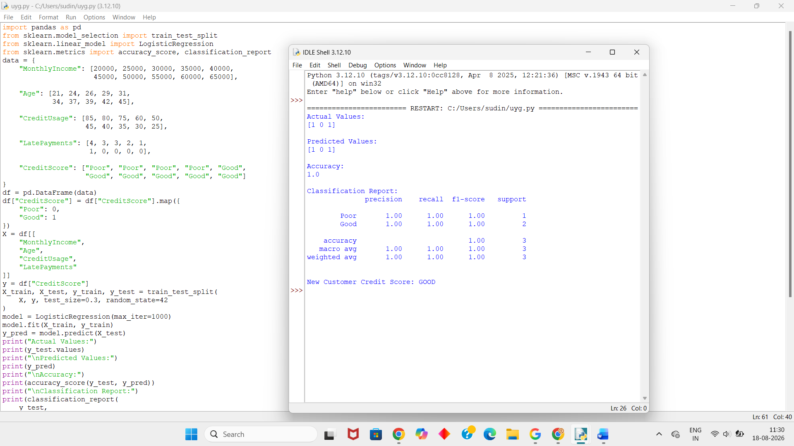
Dataset 3 – Loan Applicant Credit Classification
Income | Loan Amount | Loan Term | Previous Loans | Credit Score
22000 | 8000 | 60 | 0 | Poor
26000 | 9000 | 60 | 0 | Poor
30000 | 10000 | 48 | 1 | Poor
34000 | 12000 | 48 | 1 | Poor
40000 | 10000 | 36 | 2 | Good
45000 | 12000 | 36 | 2 | Good
50000 | 15000 | 36 | 3 | Good
55000 | 16000 | 24 | 3 | Good
60000 | 18000 | 24 | 4 | Good
65000 | 20000 | 24 | 4 | Good
Python Code:
import pandas as pd
from sklearn.model_selection import train_test_split
from sklearn.linear_model import LogisticRegression
from sklearn.metrics import accuracy_score, classification_report
data = {
"Income": [22000, 26000, 30000, 34000, 40000,
45000, 50000, 55000, 60000, 65000],

"LoanAmount": [8000, 9000, 10000, 12000, 10000,
12000, 15000, 16000, 18000, 20000],

"LoanTerm": [60, 60, 48, 48, 36,
36, 36, 24, 24, 24],

"PreviousLoans": [0, 0, 1, 1, 2,
2, 3, 3, 4, 4],

"CreditScore": ["Poor", "Poor", "Poor", "Poor", "Good",
"Good", "Good", "Good", "Good", "Good"]
}
df = pd.DataFrame(data)
df["CreditScore"] = df["CreditScore"].map({
"Poor": 0,
"Good": 1
})
X = df[[
"Income",
"LoanAmount",
"LoanTerm",
"PreviousLoans"
]]
y = df["CreditScore"]
X_train, X_test, y_train, y_test = train_test_split(
X, y, test_size=0.3, random_state=42
)
model = LogisticRegression(max_iter=1000)
model.fit(X_train, y_train)
y_pred = model.predict(X_test)
print("Actual Values:")
print(y_test.values)
print("\nPredicted Values:")
print(y_pred)
print("\nAccuracy:")
print(accuracy_score(y_test, y_pred))
print("\nClassification Report:")
print(classification_report(
y_test,
y_pred,
target_names=["Poor", "Good"],
zero_division=0
))
new_customer = pd.DataFrame(
[[45000, 11000, 36, 2]],
columns=[
"Income",
"LoanAmount",
"LoanTerm",
"PreviousLoans"
]
)
prediction = model.predict(new_customer)
if prediction[0] == 1:
print("\nNew Customer Credit Score: GOOD")
else:
print("\nNew Customer Credit Score: POOR")
Output:
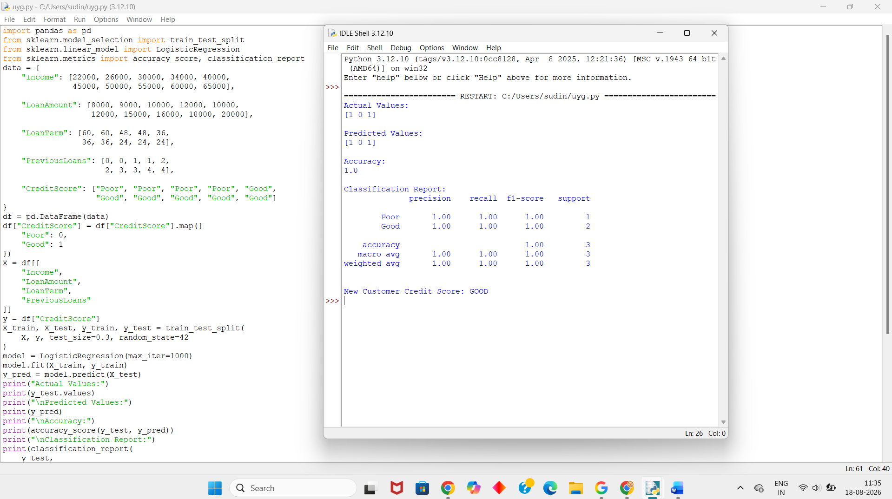
Dataset 4 – Bank Customer Credit Classification
Income | Age | Savings | Debt | Credit Score
20000 | 23 | 5000 | 18000 | Poor
25000 | 25 | 6000 | 20000 | Poor
30000 | 27 | 7000 | 22000 | Poor
35000 | 30 | 9000 | 20000 | Poor
42000 | 32 | 15000 | 15000 | Good
48000 | 35 | 18000 | 14000 | Good
52000 | 38 | 22000 | 12000 | Good
58000 | 40 | 25000 | 10000 | Good
62000 | 43 | 30000 | 9000 | Good
68000 | 46 | 35000 | 8000 | Good
Python Code:
import pandas as pd
from sklearn.model_selection import train_test_split
from sklearn.linear_model import LogisticRegression
from sklearn.metrics import accuracy_score, classification_report
data = {
"Income": [20000, 25000, 30000, 35000, 42000,
48000, 52000, 58000, 62000, 68000],

"Age": [23, 25, 27, 30, 32,
35, 38, 40, 43, 46],

"Savings": [5000, 6000, 7000, 9000, 15000,
18000, 22000, 25000, 30000, 35000],

"Debt": [18000, 20000, 22000, 20000, 15000,
14000, 12000, 10000, 9000, 8000],

"CreditScore": ["Poor", "Poor", "Poor", "Poor", "Good",
"Good", "Good", "Good", "Good", "Good"]
}
df = pd.DataFrame(data)
df["CreditScore"] = df["CreditScore"].map({
"Poor": 0,
"Good": 1
})
X = df[[
"Income",
"Age",
"Savings",
"Debt"
]]
y = df["CreditScore"]
X_train, X_test, y_train, y_test = train_test_split(
X, y, test_size=0.3, random_state=42
)
model = LogisticRegression(max_iter=1000)
model.fit(X_train, y_train)
y_pred = model.predict(X_test)
print("Actual Values:")
print(y_test.values)
print("\nPredicted Values:")
print(y_pred)
print("\nAccuracy:")
print(accuracy_score(y_test, y_pred))
print("\nClassification Report:")
print(classification_report(
y_test,
y_pred,
target_names=["Poor", "Good"],
zero_division=0
))
new_customer = pd.DataFrame(
[[50000, 34, 20000, 12000]],
columns=[
"Income",
"Age",
"Savings",
"Debt"
]
)
prediction = model.predict(new_customer)
if prediction[0] == 1:
print("\nNew Customer Credit Score: GOOD")
else:
print("\nNew Customer Credit Score: POOR")
Output:
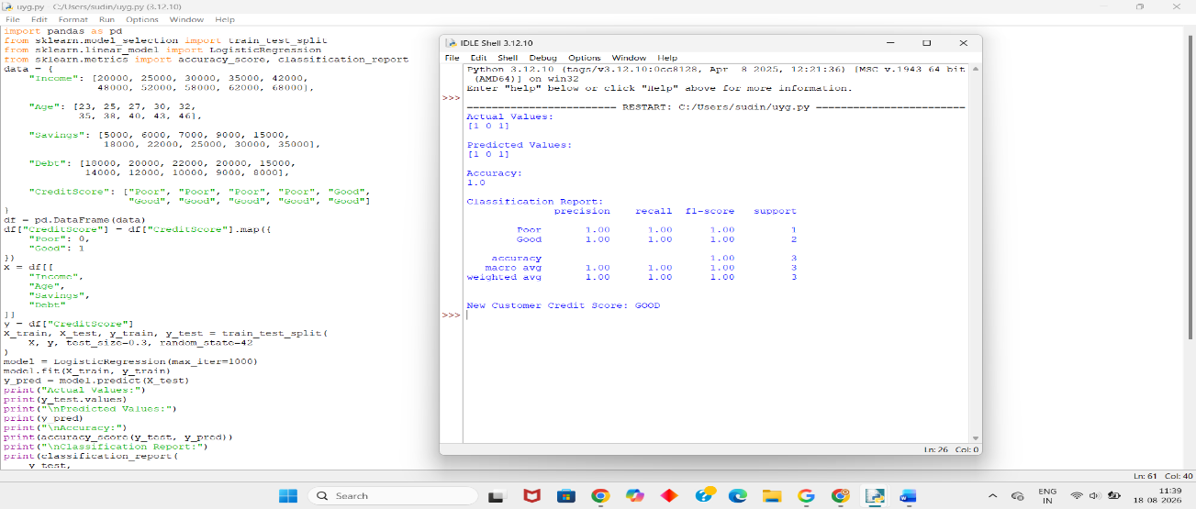
Dataset 5 – Credit Score Based on Financial Behaviour
Income | Credit Card Usage | Late Payments | Savings | Credit Score
22000 | 90 | 5 | 3000 | Poor
26000 | 85 | 4 | 4000 | Poor
30000 | 80 | 4 | 5000 | Poor
35000 | 70 | 3 | 7000 | Poor
40000 | 55 | 2 | 10000 | Good
45000 | 50 | 1 | 13000 | Good
50000 | 45 | 1 | 16000 | Good
55000 | 40 | 0 | 20000 | Good
60000 | 35 | 0 | 25000 | Good
65000 | 30 | 0 | 30000 | Good
Python Code:
import pandas as pd
from sklearn.model_selection import train_test_split
from sklearn.linear_model import LogisticRegression
from sklearn.metrics import accuracy_score, classification_report
data = {
"Income": [22000, 26000, 30000, 35000, 40000,
45000, 50000, 55000, 60000, 65000],

"CreditCardUsage": [90, 85, 80, 70, 55,
50, 45, 40, 35, 30],

"LatePayments": [5, 4, 4, 3, 2,
1, 1, 0, 0, 0],

"Savings": [3000, 4000, 5000, 7000, 10000,
13000, 16000, 20000, 25000, 30000],

"CreditScore": ["Poor", "Poor", "Poor", "Poor", "Good",
"Good", "Good", "Good", "Good", "Good"]
}
df = pd.DataFrame(data)
df["CreditScore"] = df["CreditScore"].map({
"Poor": 0,
"Good": 1
})
X = df[[
"Income",
"CreditCardUsage",
"LatePayments",
"Savings"
]]
y = df["CreditScore"]
X_train, X_test, y_train, y_test = train_test_split(
X, y, test_size=0.3, random_state=42
)
model = LogisticRegression(max_iter=1000)
model.fit(X_train, y_train)
y_pred = model.predict(X_test)
print("Actual Values:")
print(y_test.values)
print("\nPredicted Values:")
print(y_pred)
print("\nAccuracy:")
print(accuracy_score(y_test, y_pred))
print("\nClassification Report:")
print(classification_report(
y_test,
y_pred,
target_names=["Poor", "Good"],
zero_division=0
))
new_customer = pd.DataFrame(
[[48000, 48, 1, 15000]],
columns=[
"Income",
"CreditCardUsage",
"LatePayments",
"Savings"
]
)
prediction = model.predict(new_customer)
if prediction[0] == 1:
print("\nNew Customer Credit Score: GOOD")
else:
print("\nNew Customer Credit Score: POOR")
Output:
